Pabson Shivraj
Second Terminal Examination – 2082
Class: 10 Subject: C.Math F.M. 75
1. A survey was conducted among 20 students of a secondary school of class x. Where 14 students participated in football and 12 students in a volleyball game. Every student have participated in at least one game:
a. Assuming the set of students who participated in football as F and volleyball as V, write the cardinality of the set of students who participate in volleyball or football. 1
b. Present the above information in the venn diagram. 1
c. Find the number of students participating in exactly. 1
d. If two students who response only football are unable to play the game due to health problem, the cordiality of which sett is changed? Give reason. 1
2. Neeraj took loan of Rs. 40,00,000 for 2 years at the rate of 10% annual compound interest. He paid Rs. 2,40,000 at the end of first year.
a. Write the relation among principal (P) annual compound interest rate (R), time (T) and compound interest (C.I). 1
b. Find the compound interest of the first year. 2
c. How much total interest was paid by Niraj in two years? Find it. 2
3. The present population of a rural municipality is 10,000 and the population is being increased by 2% every year:
a. Write the formula to find population (P_{T}) after T year if the initial population is P and rate of growth is R%. 1
b. What will be the population of the rural municipality after 3 years? Calculate it. 2
c. In how many years will the population of rural municipality be 10,404 at the same rate of population growth? Find it. 1
4. A man exchanged some dollars for NRs 9,72,000 at the exchange rate of $1=Rs 97.20 to visit US. He cancelled his tour due to his health issue, so he exchanged his dollars to Nepali rupees after a week on that day Nepali currency was devaluated by 2%.
a. How many US dollars did he exchange in the beginning? Find it. 1
b. Find the new exchange rate after devaluation of Nepali Currency. 1
c. How much did he gain during these transaction? Find it. 2
5. A square based pyramid has it's length of a base side 10m and vertical height 12m.
a. Write the formula for finding the are of triangular surfaces of the pyramid. 1
b. Find the volume of pyramid. 1
c. By how much the area of base of pyramid is less or more than area of triangular surfaces? 2
6. A solid object made up of a cone and a cylinder is given in the figure.
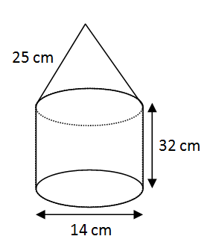
a. How many curved surface are there in the given solid
object? 1
b. Find the height of cone and volume of cone. 2
c. Compare the volume of cone and volume of
cylinder. 2
7. The radius of the base and vertical height of a conical tent are 8m and 6m respectively.
a. Write the formula for finding the curved surface area of cone. 1
b. How much canvas is required to make the tent? 2
c. Find the cost of canvas used in the tent at the rate of Rs. 50 per m². 1
8. In a survey of 120 students, 60 like to play football 48 like volleyball and 30 like cricket. Similarly 35 like football and volleyball ,10 like volleyball and cricket, 15 like football and cricket and 5 like all three games.
a. If the set of total students is U then write the cardinality of U in notation. 1
b. Present the above information in venn-diagram. 1
c. How many students do not like any game? 3
d. Compare no. of students who like to play football only and volleyball only by ratio. 1
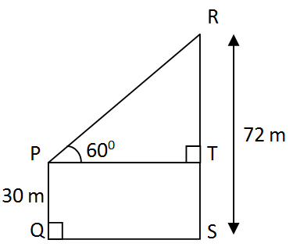
9. In the given figure along side, PQ represent the height of house, Rs represents the height of tower and QS represents the distance from the house to the tower.
a. Write the name of angle of elevation of
top of tower s observed from the roof of
house. 1
b. Find the value of TR. 1
c. Find the distance between the house and
the tower. 1
d. Is the angle of depression of 30⁰ be formed when the roof of house is observe from a point 28 m below the top of tower. Give reason. 1
10. A farmer deposited Rs 50.000 in a co-operative for 2 years to get the annual compound interest at the rate of 8% p.a.
a. How many times the interest is calculated in the quarterly compound interest in one year? 1
b. How much annual compound interest will the farmer receive at the end of 2 year? Find it. 2
c. By how much the semi-annual compound interest is more than annual compound interest of the same sum at the same rate and for the same period of time? Find it. 2
11. The population of a village is 20,000 the population increases by 2% annually in the village.
a. If the initial population is P, growth rate is R and population after T years is P_{T} then write the formula to find P_{T}. 1
b. After how many years the population of the village be 20,808? Find it. 2
c. By how much the population of village be increased in 2 years, if the annual rate of growth be 3% per annum. 2
12. A group of students constructed a square based pyramid shaped tent having length of base 24 m and vertical height 5 m.
a. How many surfaces are there in a square based pyramid? 1
b. Find the slant height of the above square based tent. 1
c. What is cost of clothes required to make tent at the rate of Rs. 125 per square meter. 2
13. Jyoti bought a tank made up of a cylinder and a hemisphere from the local market. The total height of the tank is 3.5 m and radius of base 1.05 m.
a. How many total curved and pain surface are there in a combined solid made up of cylinder and hemisphere? 1
b. Find the volume of tank. 2
c. How much maximum liters of water is contained in the tank? Find it. 1
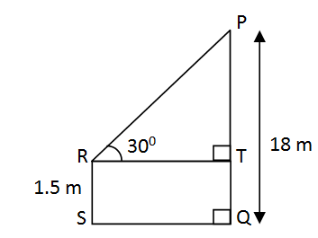
14. In the given figure, height of the electric pole PQ is 18 m and height of a man (Rs) is 1.5 m SQ represents the distance between electric pole and man where ∠PRT = 30⁰
a. Define he angle of elevation. 1
b. Find the value of PT. 1
c. Find the distance between the
electric pole and the man. 1
d. By how many degrees will the angle of elevation less or more when PT and TR are equal? Find it. 1

15. The marks obtained by 20 students in an examination with full mark 50 are given in the following table.
Marks obtain | 0-10 | 10-20 | 20-30 | 30-40 | 40-50
No. of Students | 2 | 3 | 4 | 7 | 4
a. Write the modal class of the given data. 1
b. Find the median from the given data. 2
c. Calculate the average mark from the given data. 2
d. How many maximum number of students could be there who obtained the marks less than the average mark? Find it. 1
16. A bag contain 7 black and 4 red balls of same shape and size. Two balls are drawn randomly and after another without replacement.
a. If B and R be two independent events then write the formula of
$P\left(B∩R\right)$. 1
b. Show the probabilities of all possible outcomes in a tree diagram. 2
c. Find the probability of getting both black balls. 1
d. By how much the probability of getting both red balls is more or less than the probability of getting book black balls? Find it. 1

**Best of Luck**

